Asia-China-Coin-Northern Dynasties 北魏-Northern Wei (386-534)- H 13.19, Mould

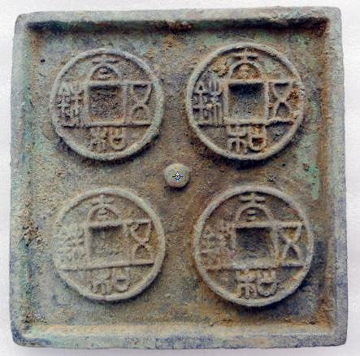

Obv:太和五蛛Tα*i He Wu Zhu* (Taihe[period] Wu Zhu), length 6.8 cm., width 7.0 cm., 162 gm., H 13.19, FD 603, S 238, R 6, Mould.

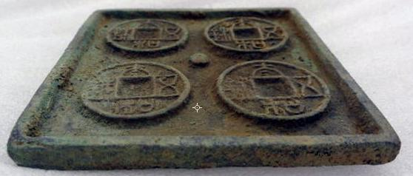 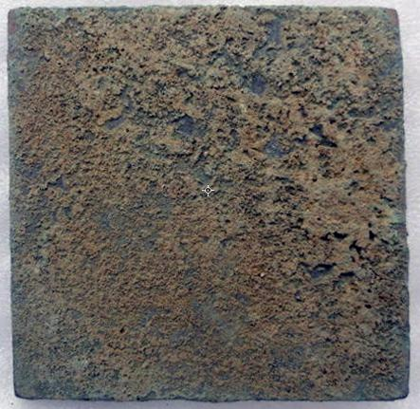

Order details Printer friendly page

Sold by

[lengxue](http://myworld.ebay.com/lengxue) ( [28](http://feedback.ebay.com/ws/eBayISAPI.dll?ViewFeedback&userid=lengxue)  )

+ Show additional actions

Delivery package 1 of 1

Estimated delivery Thursday, Jan 9, 2014 - Friday, Jan 17, 2014

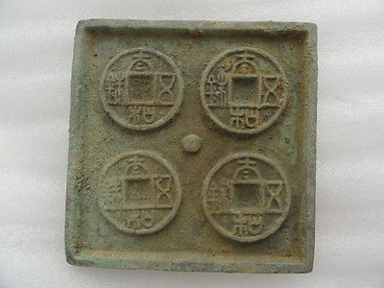

[Oriental Chinese bronze tools of the trade mould Northern wei emperor casting](http://www.ebay.com/itm/141152931900)

Item price

$9.99

Quantity

1

Item number

141152931900

Shipping service

ePacket delivery from China

[Leave feedback](http://feedback.ebay.com/ws/eBayISAPI.dll?LeaveFeedbackShow&useridfrom=802-867&useridto=lengxue&item=141152931900&transactid=906288910004) [Contact seller](http://contact.ebay.com/ws/eBayISAPI.dll?FindAnswers&frm=3998&iid=141152931900&redirect=0&requested=lengxue) [Return item](http://return.ebay.com/ws/eBayISAPI.dll?ResolveReturn&eventName=viewSelectedItem&TransactionId=906288910004&ItemId=141152931900)

### Shipping address

Ralph J Coffman Jr  
149 Atlantic Ave   
Swampscott MA 01907-2427  
United States

Phone number  
781 584 7091

### Order total

Subtotal $9.99

Shipping $10.00

#### Total

## $19.99

[View PayPal transaction](http://payments.ebay.com/ws1/eBayISAPI.dll?IntermediateResolutionInfo&itemid=141152931900&transId=906288910004&pn=UnifiedCheckoutSummaryRedirect2PP&qs=itemid%3D141152931900%26transId%3D906288910004%26buyerorseller%3D0%26)

### Order information

Order placed on  
Monday, Dec 30, 2013

Having a problem with this purchase?  
[Resolve problem](http://res.ebay.com/ws/eBayISAPI.dll?ResolutionCenter)

Payment method   
PayPal

Payment date  
Monday, Dec 30, 2013